SQL

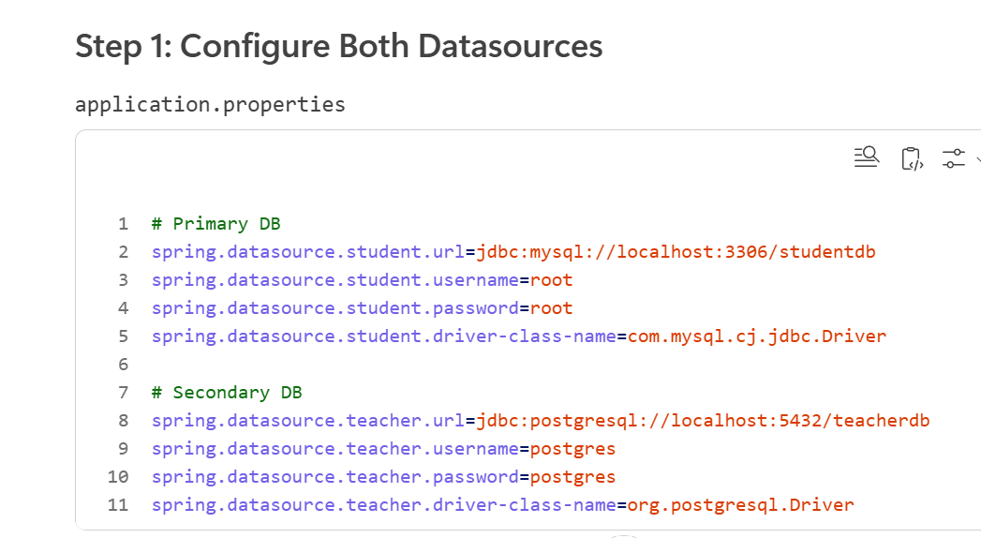

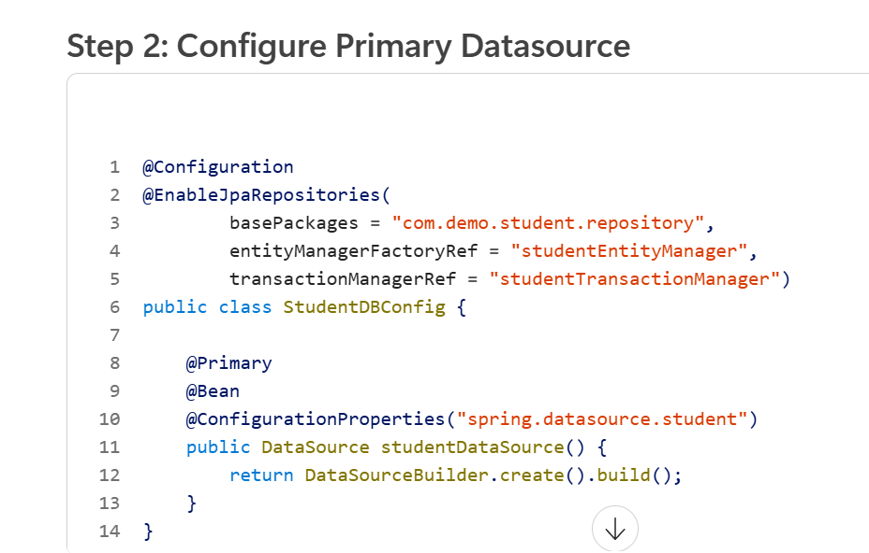

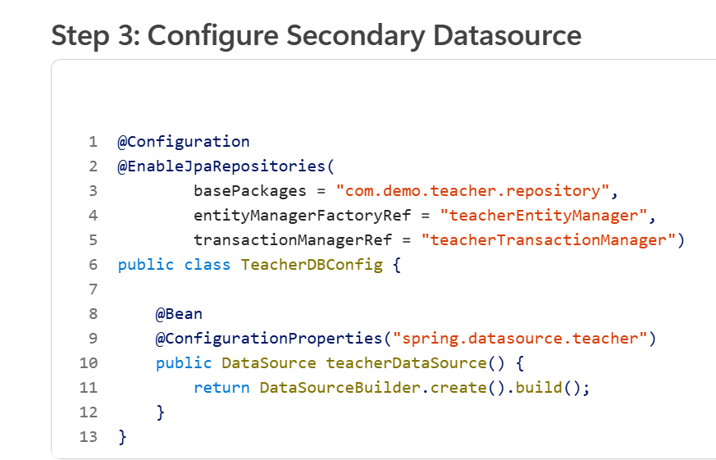

SQL + NO sql

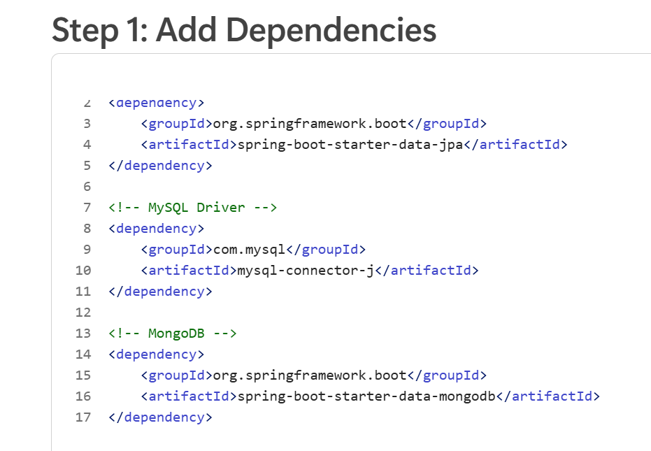

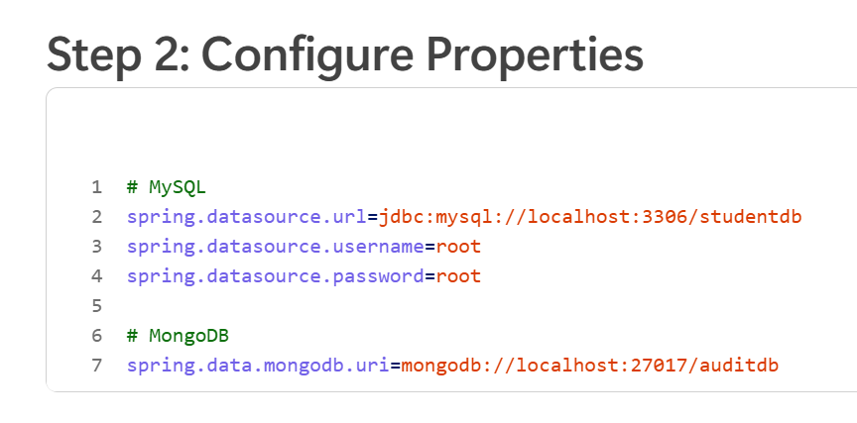

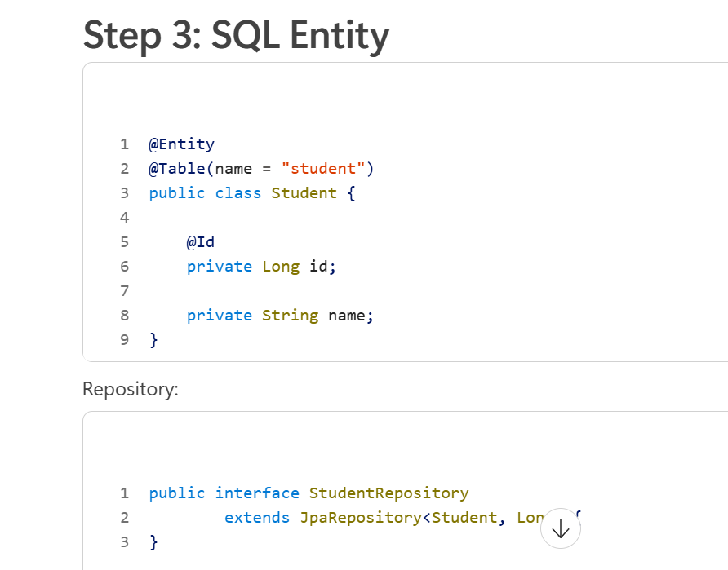

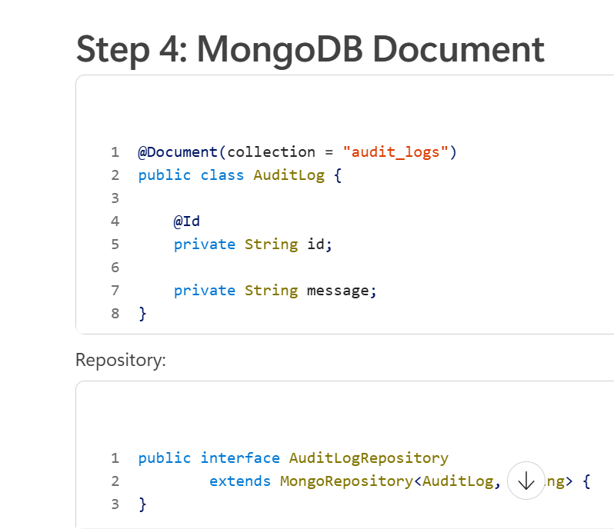

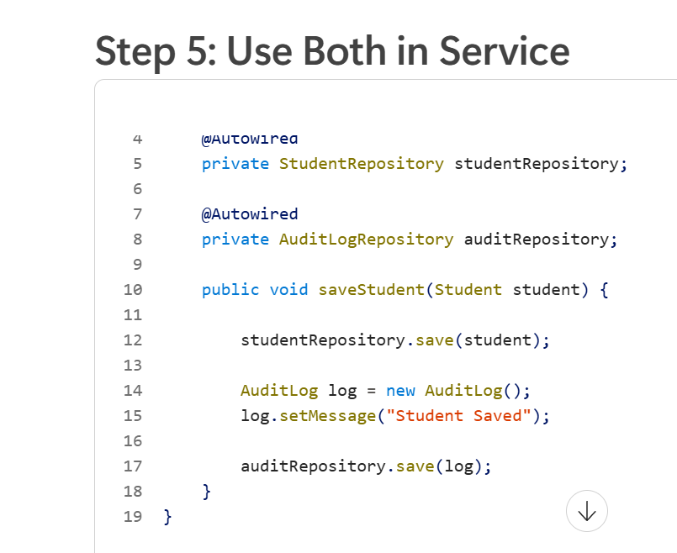

How Does HikariCP Work?
HikariCP is Spring Boot's default connection pool.

Application Starts
↓
Create Pool
↓
10 Connections Ready

spring.datasource.hikari.maximum-pool-size=20

Request
↓
Borrow Connection
↓
Execute Query
↓
Return Connection

Connections are not closed.
They're returned to the pool.

Why HikariCP?
✅ Very fast
✅ Low memory usage
✅ Better throughput
✅ Production standard

If all connections are occupied, incoming requests must wait. If a connection isn't available within the configured timeout, HikariCP throws a connection acquisition exception.

